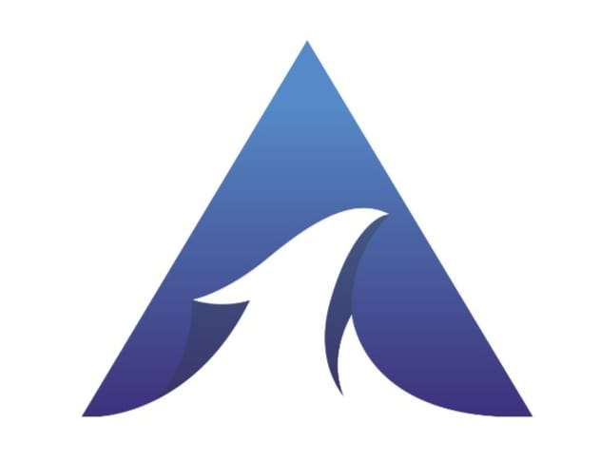 AGASTHYA SOLUTIONS

(ISO.9001: 2015 CERTIFIED)

11-5-7, Opp Ravichandra Hospital, Near

Vivekananda Park, Two town, Kakinada - 533001

📞 8019465669 📧 [info@agasthyasolutions.co.in](mailto:info@agasthyasolutions.co.in)

🌐 [www.agasthyasolutions.co.in](http://www.agasthyasolutions.co.in)

**Date: 18.11.2024**

**INDUSTRIAL TRAINING- ACCEPTANCE LETTER**

This is to inform that we accept your request to provide **Industrial Training** to your student, as requested for the period of six months i.e. **18thNOV 2024** to **22nd MAY 2025** in our organization**,** who are studying VI semester-Diploma in Computer Engineering in **ANDHRA POLYTECHNIC**, **JAGANNAICKPUR**..,

|  |  |  |  |
| --- | --- | --- | --- |
| **S.NO** | **PIN Number** | **Name of the Student** | **Student Phone**  **Number** |
| 1 | 22010-CM-083 | MOHAMMAD TAKIYOULLAH | 9014389696 |
| 2 | 22010-CM-085 | MOHAMMED HARUN | 7993916188 |
| 3 | 22010-CM-091 | NENAVATH PARAM SINGH NAIK | 7207467614 |
| 4 | 22010-CM-115 | SORANGI GOPI VINAY | 9553745369 |

**Authorized Signatory**